Question 1 :

**Code:**

CREATE TABLE SUPPLIER

( supplier_id NUMBER(10) PRIMARY KEY,

supplier_name VARCHAR2(50) UNIQUE,

contact_name varchar2(50),

phone_no varchar2(10) UNIQUE,

city varchar2(10),

Region VARCHAR2(3)

CONSTRAINT check_region

CHECK (Region IN ('N', 'NW', 'NE', 'S', 'SE', 'SW', 'W', 'E') )

);

Result Image:

Q1: create table

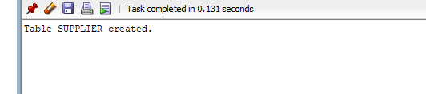

Q1-1: add five results

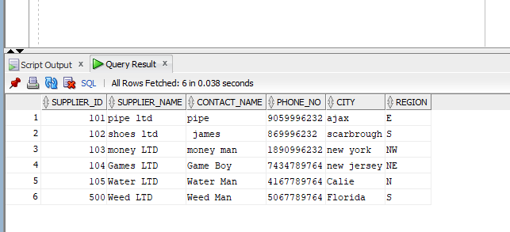

Q1-2: Display the details of the supplier who comes from Florida and their supplier id 500

select * from supplier where REGION = 'Florida' AND SUPPLIER_ID = 500;

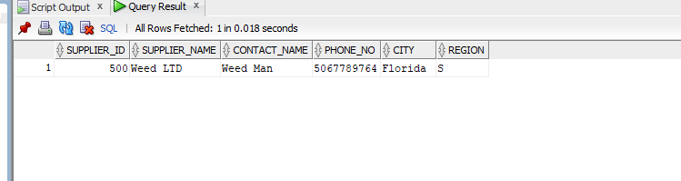

Q1-3 : Add phone number in the supplier table using DDL command

ALTER TABLE supplier ADD (phone_number number(10));

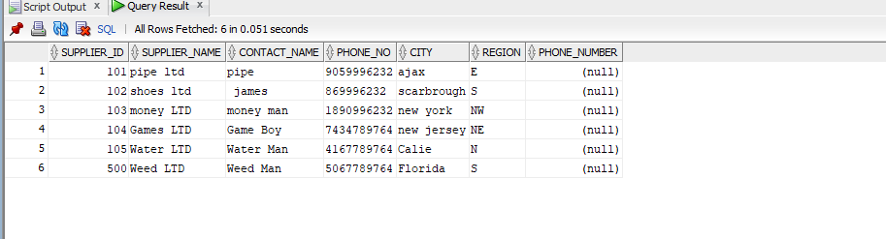

Q1-4: Delete the unused column in the supplier table

ALTER TABLE supplier DROP COLUMN PHONE_NUMBER;

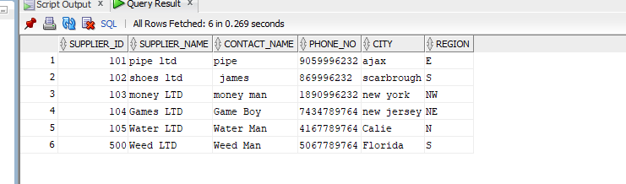

Q1-5: drop supplier table

Code: drop table supplier;

Q1-6:

Code:

CREATE VIEW supplier_contact AS

SELECT SUPPLIER_ID, SUPPLIER_NAME,PHONE_NO

FROM supplier;

[The code would not run because I dropped the table in the table in the previous question

Question 2 :

Q2-1: Create flow chart

Display total shipping Cost

Calculate shipping Cost

With

Membership Discount

Calculate shipping Cost

Without

Membership Discount

Member?

Retrieve membership status

And

Number of items bought

Q2-2 : Create a pl/sql block to complete the above task. Include variable that holds Y OR N to include membership status and a variable to denote the number of items purchased. Verify with different values

DECLARE

MEMB_STAT CHAR(1):='N';

NUM_ITEMS NUMBER(9):='16';

SHIPPING_COST NUMBER(10,2);

TOTAL_COST NUMBER(10,2);

BEGIN

IF MEMB_STAT = 'Y' THEN

IF NUM_ITEMS >10 THEN

SHIPPING_COST := '7.50';

ELSIF NUM_ITEMS BETWEEN 7 AND 10 THEN

SHIPPING_COST := '5.00';

ELSIF NUM_ITEMS BETWEEN 4 AND 6 THEN

SHIPPING_COST := '3.50';

ELSE

SHIPPING_COST := '4.00';

END IF;

TOTAL_COST := SHIPPING_COST * NUM_ITEMS;

DBMS_OUTPUT.PUT_LINE('SHIPING COST FOR THIS MEMEBR IS $'|| SHIPPING_COST);

DBMS_OUTPUT.PUT_LINE('Total Shipping cost is $'|| TOTAL_COST);

ELSE

IF NUM_ITEMS >10 THEN

SHIPPING_COST := '15.00';

ELSIF NUM_ITEMS BETWEEN 7 AND 10 THEN

SHIPPING_COST := '10.00';

ELSIF NUM_ITEMS BETWEEN 4 AND 6 THEN

SHIPPING_COST := '7.00';

ELSE

SHIPPING_COST := '8.00';

END IF;

END IF;

TOTAL_COST := SHIPPING_COST * NUM_ITEMS;

DBMS_OUTPUT.PUT_LINE('SHIPING COST FOR NON MEMEBR IS $'|| SHIPPING_COST);

DBMS_OUTPUT.PUT_LINE('Total Shipping cost is $'|| TOTAL_COST);

END;

Question 3:

Create table

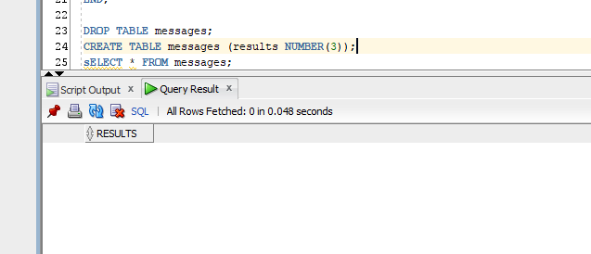

Q3-B : plsql code

DECLARE

U_TOTAL NUMBER(7);

BEGIN

FOR LP IN 1..10 LOOP

IF LP = 6 OR LP = 8 THEN

CONTINUE;

END IF;

INSERT INTO messages

VALUES (LP);

END LOOP;

END;

Results

